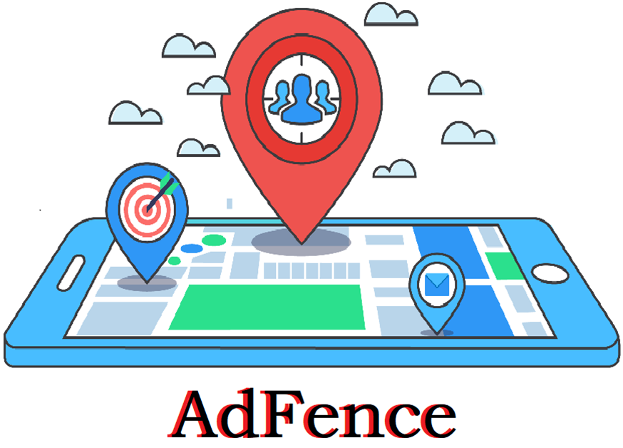

**The Technology**

**The Project Review**

A Location based geofencing application for product advertisement



Geofence Technology

**Aim**

**This project is an attempt to improvise and enhance the advertisement system using the geo-fencing technology.**

**Abstract**

**AdFence is a location based mobile application for product advertisement. The application is based on the geo-fencing technology to deliver location-based services to the users.**

**The application is basically aimed at advertising using the google maps by creating and setting a geo-fence of certain radius. A user can register a geo-fence (area of advertisement) on the map in the application. The geo-fence is characterized by the events in its entry, exit and inside of geofence section. Whenever a user enters or exits a particular geo-fence a series of event or activity triggers can be alerted to the user through a notification in the application.**

**The user as an advertiser must set a geofence of a particular radius on the google map in the application. The geo-fence must be provided with the details of its category (Shopping, Restaurants, Medical etc...).**

**The user as a normal user can discover geo-fences according to his preference on the map during his free roam.**



Location tracking

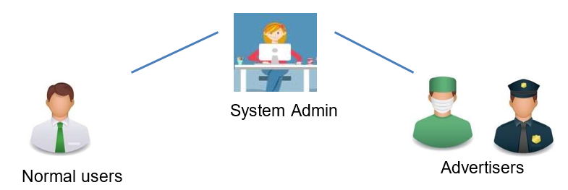

Participants

**Objective**

**The project aims to create a mobile application based on geo-fencing technology for the purpose of product advertisement.**

* **The primary objective of the project is to provide the individuals and small scale retailers a platform to advertise their products through a mobile application at zero cost and to increase their reachability and sales which will help them to stay in the competition against the bigger retail contenders.**
* **To help the advertisers to attract the right customers and to help the customers as in the individuals in discovering the right retailers of their interest for mutual benefits.**



Project carried out by

* R. Sriram (1MV14CS076)
* Ranjith D (1MV14CS084)
* Sanjay C (1MV14CS091)
* Rakshith K (1MV15CS413)

Dept. of Computer Science Engineering, SIR MVIT, 2018-17

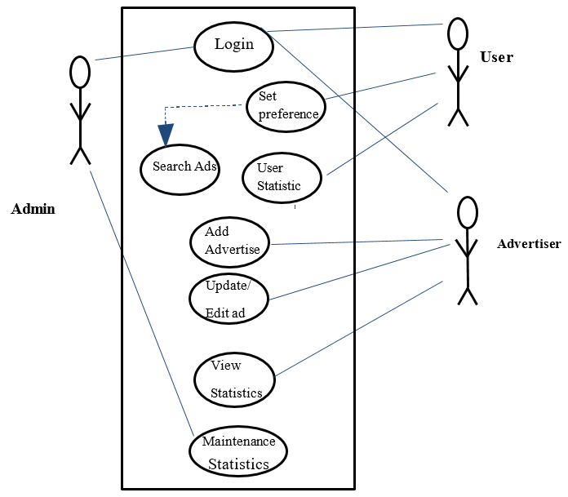

Workflow

**Implementation Requirements**

* **A Smartphone**
* **Location service must be enabled**
* **Internet and GPS**

**Conclusion**

**Future Enhancements**

**The data collected from the application will be very much useful in analysing the advertisement trends, customer targeting and also can be used to predict the product and market trends in the future.**

**The basic android application with all the modules described in the project report has been achieved. The production version of the application for real-time market is under progress.**